End-to-End DevSecOps CI/CD Pipeline Project

This project demonstrates a complete DevSecOps CI/CD pipeline using Jenkins, GitHub, Maven, SonarQube, Docker, Trivy, Docker Hub, and Docker Swarm.

Architecture / Pipeline Flow
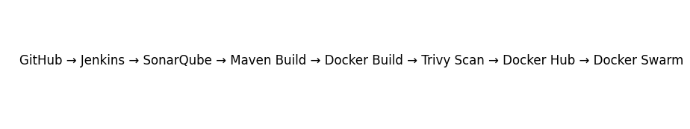

Project Overview
Automated software delivery lifecycle with integrated code quality validation, security scanning, containerization, and deployment.

Tools & Technologies
GitHub, Jenkins, Maven, SonarQube, Docker, Trivy, Docker Hub, Docker Swarm, Linux.

CI/CD Workflow
1. Source Code Checkout
2. SonarQube Analysis
3. Maven Build
4. Docker Image Creation
5. Trivy Vulnerability Scan
6. Docker Hub Push
7. Docker Swarm Deployment

Key Achievements
Implemented DevSecOps practices, automated deployments, vulnerability scanning, and production-style container orchestration.

Here I created a three instances as shown in the below :
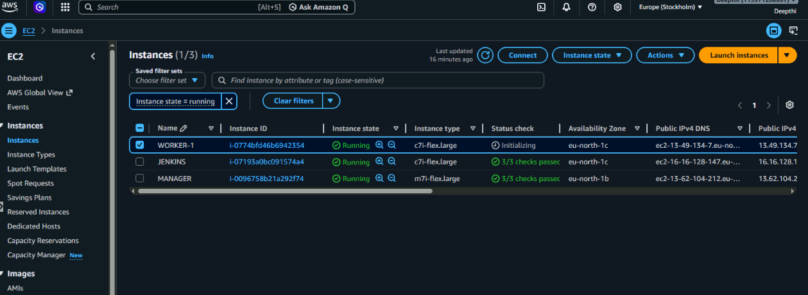
JENKINS DASHBOARD
Here is using the Jenkins pipeline we have pull the source code form github : https://github.com/venkatadeepthi79-svg/dockerwebapp

Performed the image check using the SonarQube
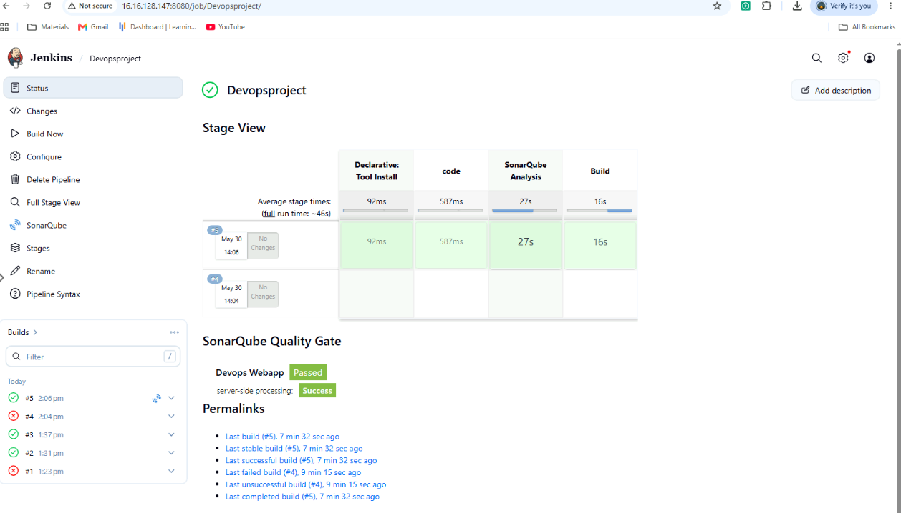

SonarQube validation:
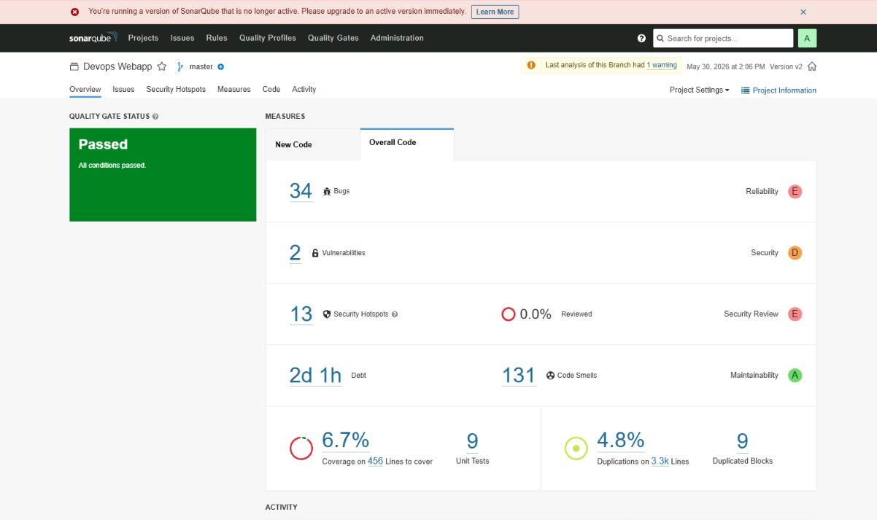
Error: Faced the error during the building the image:

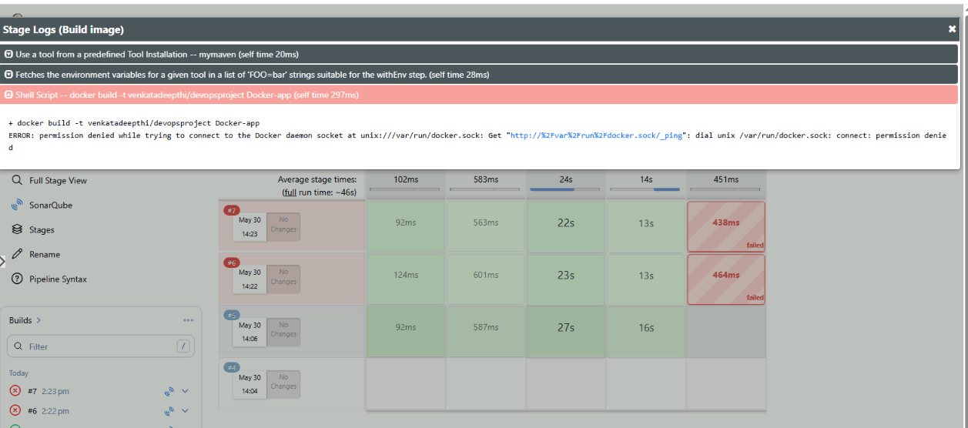

Once the Docker images were built successfully, Trivy was used to scan them for vulnerabilities and security compliance issues.

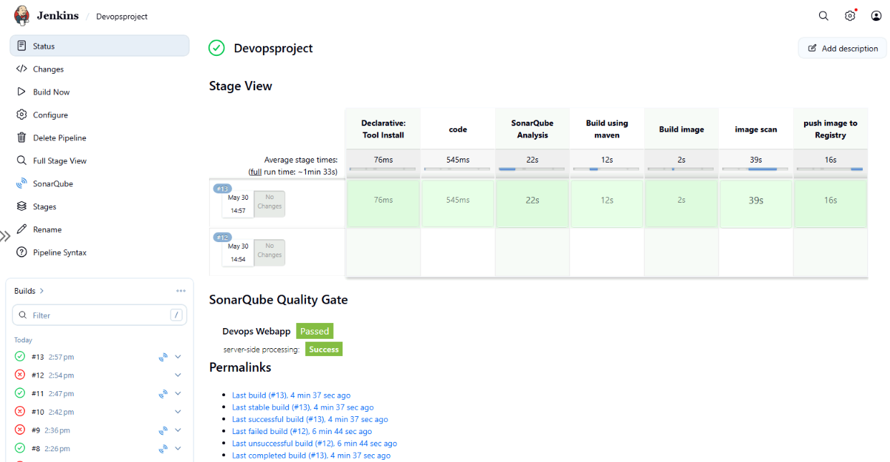

Trivy image scan report :

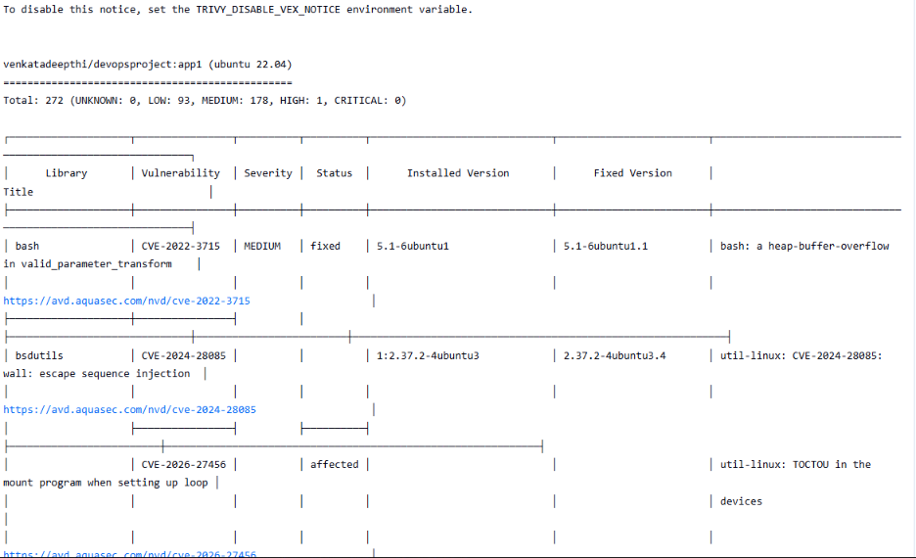

After successfully scanning the image , image will be pushed to registry

DockerFile :
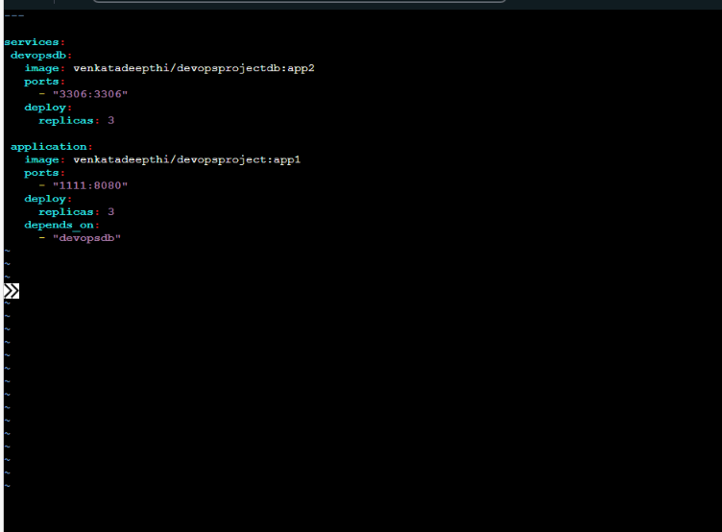

Application is deployed successfully
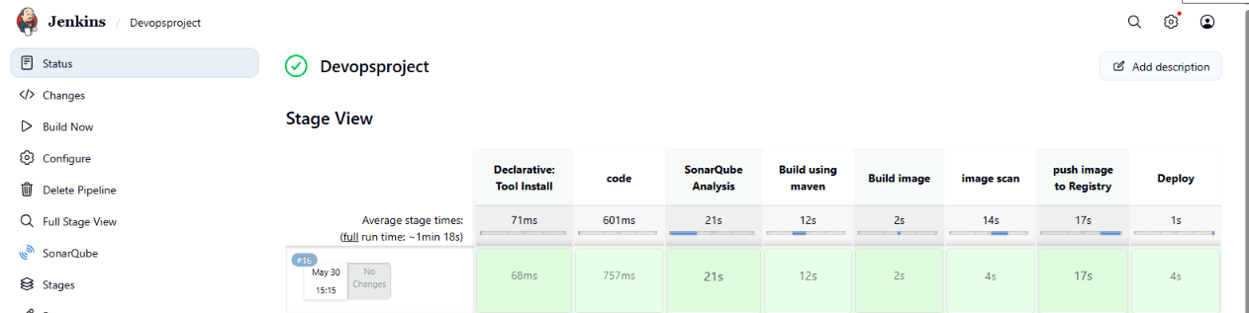

Application login page:
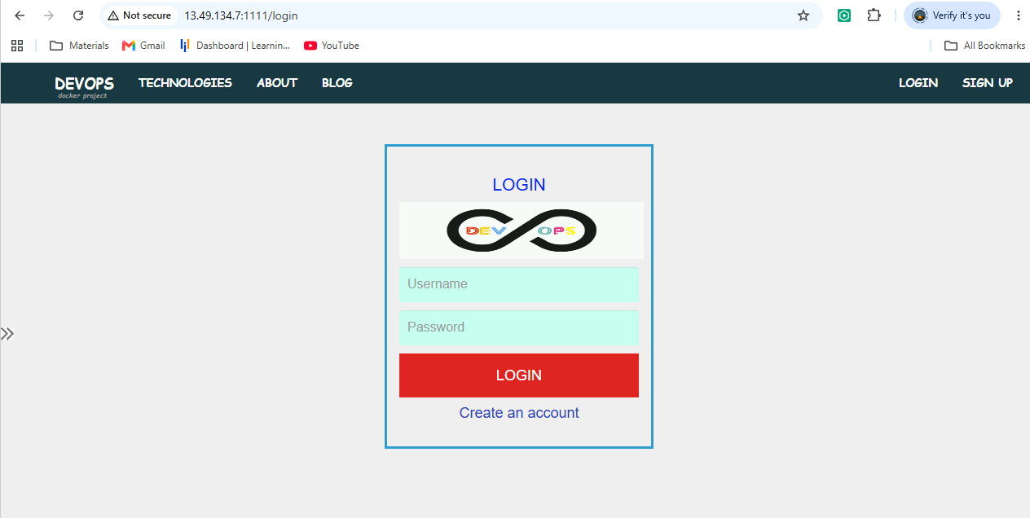
Here we can give the login details this will be stored in the database end.
